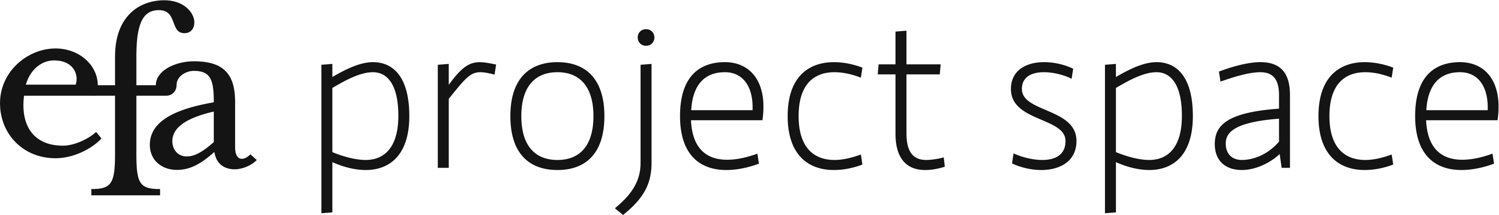

CURRICULUM: spaces of learning & unlearning
January 16 – March 16, 2018

Curated by: Stamatina Gregory & Jeanne Vaccaro
Curatorial Fellow: Java Jones

OlaRonke Akinmowo for Free Black Women’s Library
Free Black Women’s Library, 2018 (on going)
Installation with video.
Dimension variable.

Becca Albee
SERIES TITLE: RADICAL FEMINIST THERAPY (WORKING IN THE CONTEXT OF VIOLENCE, B.B. 1992), 2016,
Letterpress prints and shadow-registered emboss on 77 gsm Masa printed at Publicide INC.
6 x 9 in each, plus frames:

Introduction
1. The Radical Feminist Foundations
2. Psychiatry
3. Basics and Beginnings
4. General Empowerment Work
5. Difference: Working With…
6. Problematic Territory
7. Working With Adult Survivors of Childhood Sexual Abuse
8. Extreme Abuse by Male Partner
9. Working With Women Subject To..
10. Self-Mutilation
11. Trouble Eating
12. Drinking Problems
13. Working with Psychiatric Survivors
14. Clients Who Are Considering Ending Their Lives

Amelia Bande
Is It Our Anger That Makes Us So Beautiful?, 2019
Performance.
Saturday, March 9, 2019.

Lukaza Branfman-Verissimo
Storyteller 2, 2017
Photographed in collaboration with Azha Luckman.
Digital and film inkjet print. Ed 1 of 1 + 1 AP.
30 x 40 in.

The Storyteller of the Future’s Altar, 2017
Painted canvas, fabric, homemade candles, sacred objects.
22 x 22 x 17 in.

As Bright as Yellow Manifesto, 2018-2019
Riso print.
Varied sizes.
Please take one.

Christen Clifford
Interiors: We Are All Pink Inside, 2018
Plexiglass, fabric, video, wood, paint, projection.
132 × 96 × 96 in.

January Hunt
Untitled (Sound Installation), 2019
Sound installation with objects.
Dimensions Variable.

Carolyn Lazard
Crip Time, 2017
Video.
10 minutes, 20 seconds.

Candice Lin & Patrick Staff
Hormonal Fog, 2016-2018
Installation with altered fog machine.
Dimensions Variable.

Julie Tolentino
Conversation Piece (from .bury.me.fiercely.), 2019
Performance & Performance Ephemera.
Dimensions Variable.
Wednesday, January 16, 2019 & Saturday, January 19, 2019

Quay Quinn Wolf
My Man's Gone Now Ain't No Use a Listenin' for His Tired Footsteps Climbin' Up the Stairs, 2018
Red pearl pins, red carnations, red shirt, inverted plant support.
41 1/2 × 14 × 13 1/2 in.
Sarah Zapata
To Teach or Assume Authority, 2018
Natural and synthetic fiber, handwoven fabric, pine.
144 x 144 x 84 in. (approximate)

