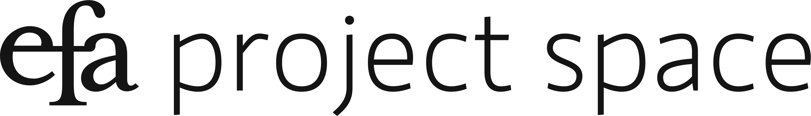

Temporary Island
June 26 – August 3, 2019

Checklist

Pradeep Dalal
Illuminator (Mir Ali_A_cobalt), 2019
Archival inkjet print
12 x 18 in.
Illuminator (Mir Ali_B_umber), 2019
Archival inkjet print
12 x 18 in.

Illuminator (Mir Ali_C_yellow), 2019
Archival inkjet print
12 x 18 in.

Illuminator (Mir Ali_D_carmine), 2019
Archival inkjet print
12 x 18 in.

Illuminator (Mir Ali_e_ochre), 2019
Archival inkjet print
12 x 18 in.

Srirangam (QV 1 back), 2019
Archival inkjet print
12 x 18 in.

Srirangam (QV 2 head), 2019
Archival inkjet print
12 x 18 in.

Srirangam (QV 3 profile), 2019
Archival inkjet print
12 x 18 in.

Srirangam (canopy), 2019
Archival inkjet print
12 x 18 in.

Srirangam (plinth 1), 2019
Archival inkjet print
12 x 18 in.

Srirangam (plinth 2), 2019
Archival inkjet print
12 x 18 in.

Srirangam (plinth 3), 2019
Archival inkjet print
12 x 18 in.

Srirangam (portraits), 2019
Archival inkjet print
12 x 9.3 in.

Srirangam (cascade 1H), 2019
Archival inkjet print
6 x 9 in.

Srirangam (cascade 2H), 2019
Archival inkjet print
6 x 9 in.

Srirangam (cascade 1S), 2019
Archival inkjet print
6 x 9 in.

Srirangam (cascade 2S), 2019
Archival inkjet print
6 x 6 in.

Srirangam (Night), 2019
Archival inkjet print
12 x 18 in.

Matthew de Leon
Untitled Queen Wearing Paper Dress, 2018
Colored pencil and pen on vellum paper
11 x 14 inches

No Man Is An Island, But This Queen Is, 2018-19
Mannequin, vellum, gouache, watercolor, chicken wire, tape, paper, fabric, stuffing, spray paint, pen on paper drawings
Size variable

Mom's Garden, 2019
Pen on paper
22 x 30 inches

Alicia Enhi
Paracas the Wind, 2019
Video
3 minutes

Untitled, 2019
10 works framed with plexiglass and hardware,
Dimensions vary

Nung-Hsin Hu
Eternal Return (Mushrooms), 2019
Bark mushrooms, onionskin paper, archival ink
Size variable

Eternal Return (Film Installation), 2019
16mm color and B&W film loop, 16mm analog projector, plastic mirror
Size variable

Eternal Return (Risograph prints), 2019
Risograph prints on black Noir Plike paper
8 1/2 x 11 inches each

Patrick Rowe
Threshold, 2019
Acrylic on paper, aluminum blueprint clamps
117 x 77 inches

Codex (Triptych), 2019
Acrylic and photographs on paper with aluminum blueprint clamps
42 x 72 inches each

Maya Valladares
Make Time, 2019
Cut and sewn fabric
82 x 38 inches

Annette Wehrhahn
Large Lips, 2019
Watercolor and oil paint on linen
48 x 60 inches

Essentials, 2019
Watercolor and oil stick on linen
48 x 60 inches

Mostly Human, 2019
Watercolor and oil stick on linen
82 x 86 inches

Tiny Mouth, 2019
Oil on linen
44 x 59 inches

